Innovation # 888
Enhanced Lab Order Menu
Contract # VA118-11-D-1000
Task Order # VA118-1000-0030

User Manual
Version 1.0



Prepared by:

Systems Made Simple, Inc.
149 Northern Concourse
Syracuse, NY 13212

April 2015

Date | Version | Description | Author
04/03/2015 | 0.1 | Initial DRAFT document | Richard Feigel
04/30/2015 | 1.0 | Final document | Richard Feigel

1 Introduction 2
1.1 Purpose 2
1.2 Scope 2
1.3 Assumptions and Dependencies 2
1.4 Acronyms and Definitions 3
2 Application startup 4
2.1 Open Browser 4
3 Approval Signatures 11

Introduction
This Enhanced Lab Order Menu User Manual is presented by Systems Made Simple (SMS) to the Department of Veterans Affairs (VA). This deliverable and its solutions are required per the contract.
Veterans Health Administration (VHA) management has embraced the principle of innovation to determine areas for possible improvements in the current Veterans’ health care system. These innovations along with the move to modernize the CPRS system to the new enterprise Health Management Platform (eHMP) will streamline the process for Veterans’ patient care.
The Enhanced Lab Order Menu project was established with the following primary goals:
- To combine multiple independent menu items to a single screen.
- To improve the workflow and reduce the time spent on ordering lab tests for patients.
- To increase the size of the General Ward Instruction box to eliminate the need for scrolling thru multiple lines of instructions.
- To highlight the Turnaround time to decrease the possibility of ordering tests that will not return results in a timely manner.
This document describes how to use the Enhanced Lab Order Menu (ELOM) software.

Purpose
The purpose of this manual is to provide instructions for a User to use the Enhanced Lab Order Menu (ELOM) application.
The installation described in this document is for a standalone instance of the software, not the ELOM software integrated into the eHMP application.

Scope
The scope of information in this document is the use of the functionality changed by the Enhanced Lab Order Menu. This document will be kept current for the software produced in each sprint of the development cycle.
This plan assumes baseline Virtual Machines (VMs) have been created with the appropriate Operating System (OS) (e.g., Red Hat Enterprise Server, 64-bit) and application software (e.g., Oracle WebLogic, VistA database, and so on). The instructions in this plan deal with the configuration of the baseline VM and the deployment of the ELOM application.
All continued customizations is based on Government selected prioritization and the ability to change and release new documentation must be executed in accordance with an agile methodology. SMS shall continue to provide information and training to the VHA trainers so that the information can be used to train and communicate with the end users.

Assumptions and Dependencies
Users of this document are assumed to have a working knowledge of the current menus and functionality of the CPRS system.

Acronyms and Definitions
Through the life of the project, SMS will follow the prevailing use of acronyms within the VA, many of which are published on the VA Information Resource Center Acronym Lookup and Glossary.

Table 1: Acronyms
Term | Definition
API | Application Programming Interface
COTS | Commercial-off-the-Shelf
CSS | Cascading Style Sheet
DB | Database
FTP | File Transfer Protocol
FTPS | File Transfer Protocol-Secure
HTML | Hyper Text Markup Language
HTTP | HyperText Transfer Protocol
ID | Identification
IE | Internet Explorer
IP | Internet Protocol
OS | Operating System
SCP | Secure Copy
SFTP | SSH File Transfer Protocol
SMS | Systems Made Simple, Inc.
SQA | Software Quality Assurance
SSH | Secure Shell
SSL | Secure Socket Layer
UAT | User Acceptance Testing
URL | Uniform Resource Locator
VA | Department of Veterans Affairs
VHA | Veterans Health Administration
VM | Virtual Machine
VPN | Virtual Private Network

Application startup

Open Browser
- Open up a Chrome browser, enter the following URL:
https://localhost:8080/ewd/ewd/elom/index.html
Note: Instead of localhost, enter the machine where the Elom Demo has been installed.

- The following screen should appear.

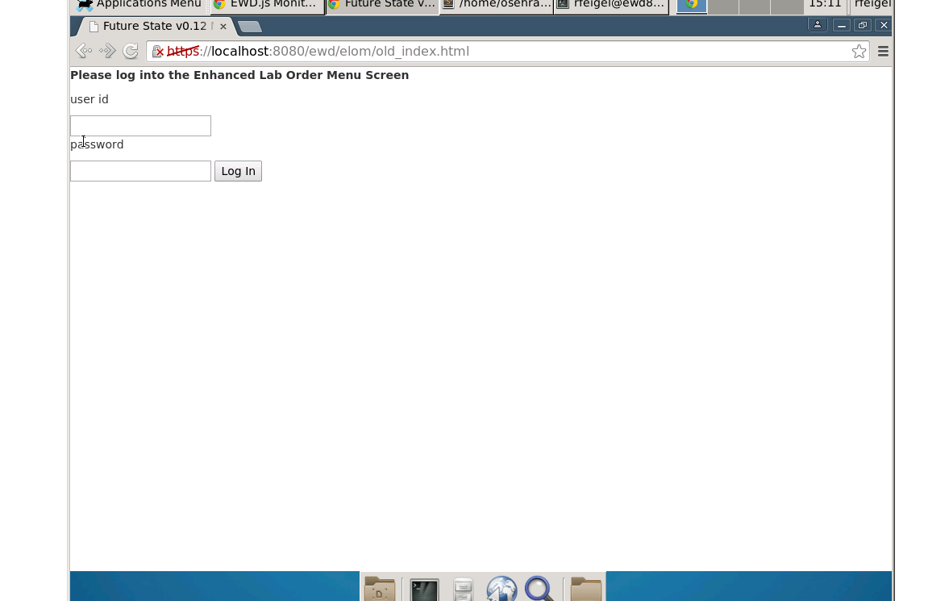

- This is a demonstration Log in screen; click the Log In button to continue. The following Lab Order screen should appear.

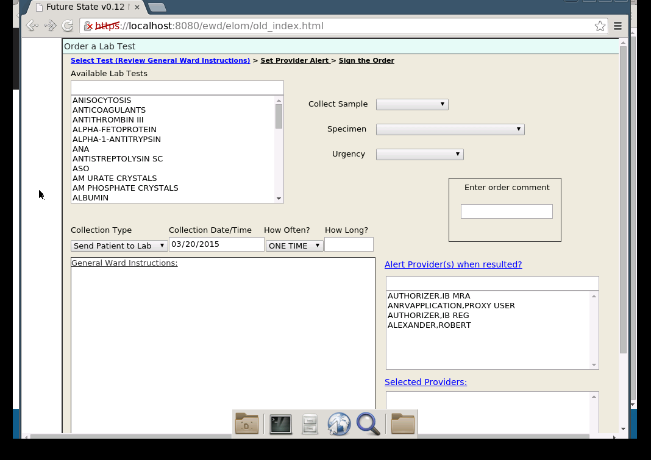

Note: The actual names in the Lab Test list and the Alert Provides List will vary depending on the database.
- If you see the Lab test you want in the Available Lab Test List, click on it to select it. If you do not enter the first few characters of the Lab test you are looking for. For example if you are searching for GLUCOSE, enter a g in the field above the list. You should then see the list something like below. Remember the actual data shown is dependent on the database you are using. Continue typing the name of the lab test you want and the list should narrow until you see the test you want.
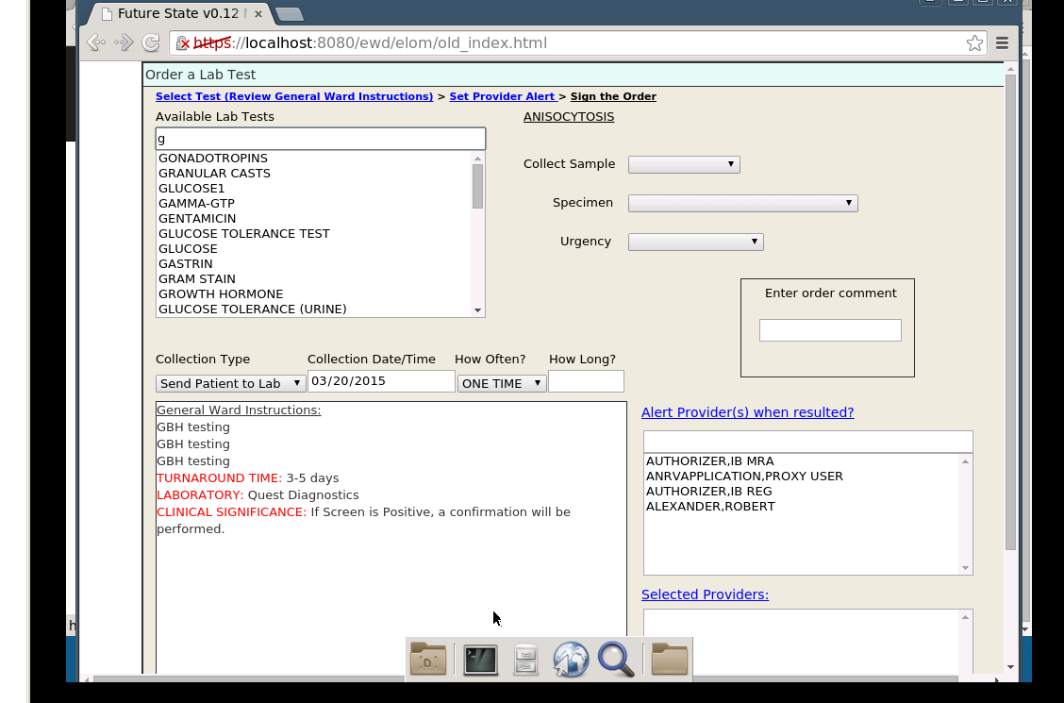

- When you select the Lab test you want you will see that the selected values in the Collect Sample, Specimen and Urgency fields will change. These are the suggested defaults for the Lab test you selected. You can accept these or choose a different value. You will also see the General Ward Instructions for the selected lab test displayed.

- You can also enter values for Comments, Collection Type, Collection Date/Time, How Often? and How Long? Below is an example.

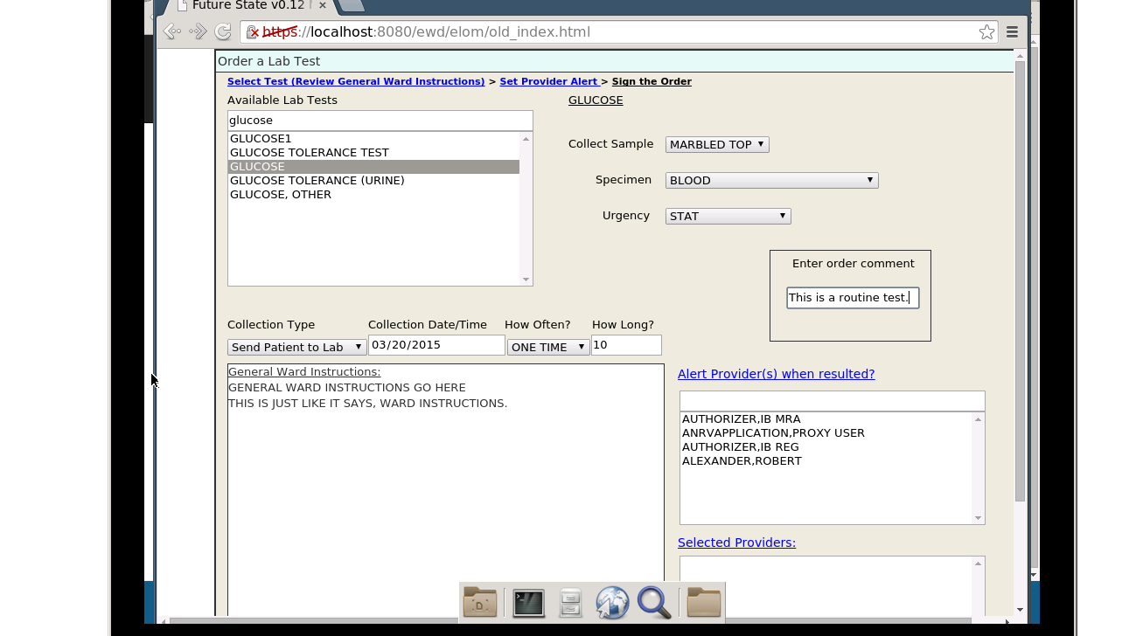

- You are now ready to select the medical providers who should be alerted regarding the results of the Lab test. The field above the List of Providers works similar to the Lab test selection field. If you do not see the provider in the list, begin typing the name you are looking for. The more letters you type, the narrower your list of choices becomes. When you see the name(s) you are looking for, click the name. When you do this you will see the selected name appear in the Select Providers List. Select as many names as you need. The screen below shows two Providers as being selected.

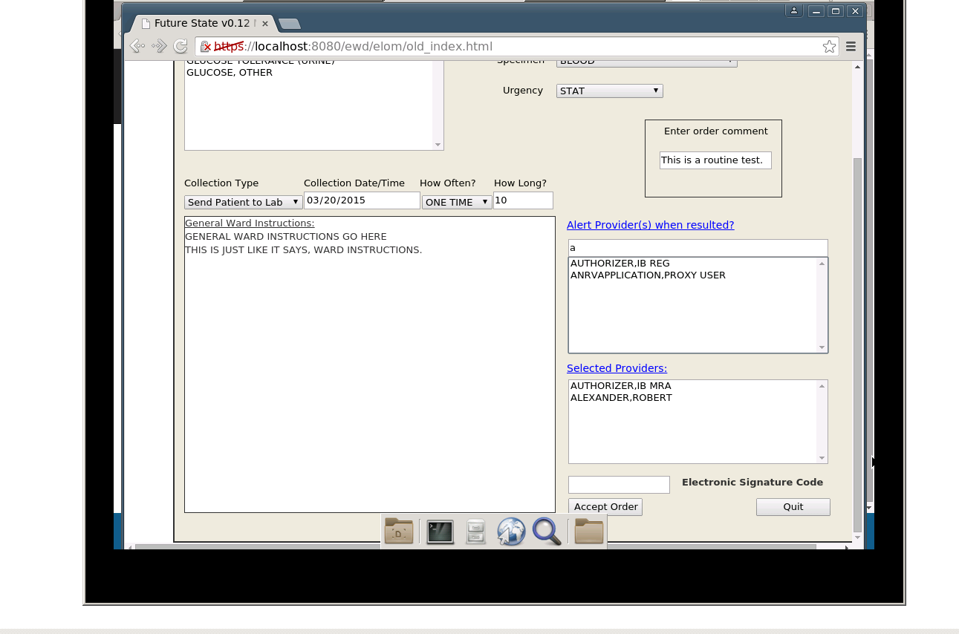

If you select a Provider in error, you can remove the provider from the Selected Provider list by clicking the name you want to de-select. This will remove the Provider name from the Selected Provider list and move it back to the list above.

- To complete the Lab order, enter the Electronic Signature Code and click the Accept Order button. This will save the Lab Order.

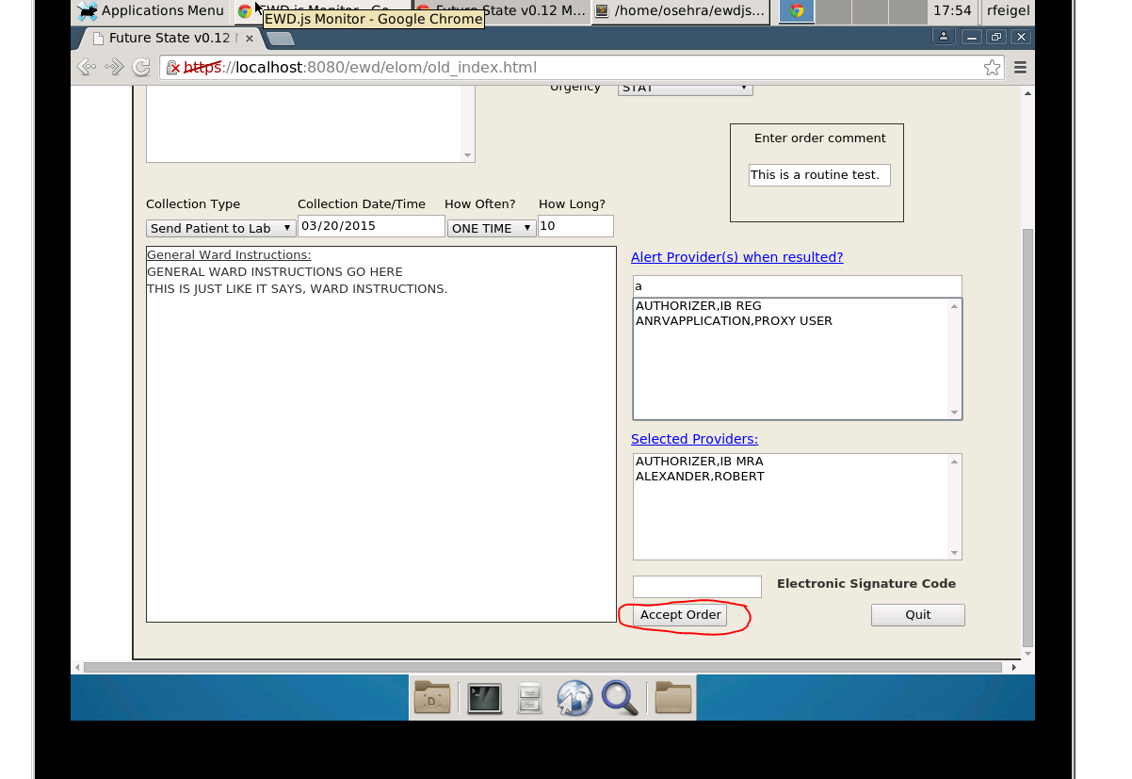

When the Lab Order is saved you will see the following message.

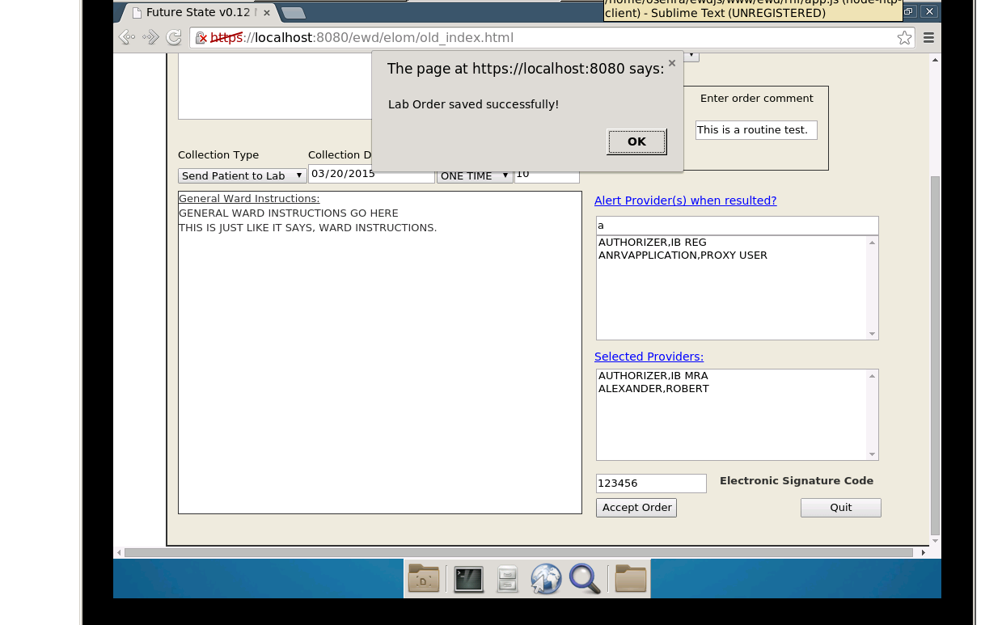

Approval Signatures
This section is used to document the approval of the Innovation #888 Enhanced Lab Order Menu Installation Plan during the Formal Review. The review should be conducted face to face where signatures can be obtained “live” during the review.
If unable to conduct a face-to-face meeting then it should be held via LiveMeeting and concurrence captured during the meeting. The Scribe should add /es/name by each position cited.
Please annotate signature blocks accordingly.

Version: | DRAFT
Review Date: | <MM/DD/YYYY>
Scribe: | <Name>
<NAME> |  | Date:
Program Manager
<NAME> |  | Date:
Contract Officer’s Representative

